­­­­VIA UNIVERSITY COLLEGE

ICT ENGINEE­RING

# Process Report

Internship 101

Andrei Mihai Surueanu 240370

Robert Iulian Zainea 240000

Supervisors

Henrik Kronborg Pedersen (HEKP)

Stephan Erbs Korsholm (SEK)

June 2016

SEPI2-S16, Group 10

As a methodology we use primarily SCRUM. During the project period we divided the tasks between each other and also we shared the SCRUM roles, taking into consideration the fact that we are a team consisting only of two members. The Scrum Master, Product Owner and Scrum Team roles were switched back and forth from one to another, making sure that either we had all the tools necessary to perform and do our job and making sure that the obstacles that were occurring were disposed, these are, of course, responsibilities of the Scrum Master. We made sure that at the end of each sprint one of us or both agreed that the tasks intended for that specific sprint are accomplished or that they are not finalized just yet.

For our project we decided to use user story points to keep track of our activity and our progress through the project. The length of our sprints is 2 days, and a total of 12 working days, excluding weekends.

We met up every day. For the first week and a half we met up around 11 or twelve in the morning/noon, spending an average of 3 to 4 ours. In the last three sprints, week, before the hand-in we met up much earlier, starting from 10 – 10:30 ending up meeting at 9:30 in the morning and spending an average of 6 to 8 hours.

# Burndown chart

The fist sprint was intended to cover the creation of the Java Project, packages, Classes and we managed to accomplish these tasks.

In the second sprint we started working on creating a Main menu Frame, from which you could choose to Login as a Student or as a Company or to Register. We managed to do that as well in time and to accomplish the 2nd sprint’s goal.

In the third and fourth sprint we implemented the Log-in and Register functions, both in terms of Graphical User Interface, as well as functionality in code and in Database.

We used also Inception that is part of the Unified Process that is in general cases performed in an agile style. This happened the first day when we started the work, to figure out what is this project all about. We wrote in our computers some functionality that the program should have, which are very similar to user stories. Just below you can find these Inception phase materials that we putted in here just as a delight for you.

**“**

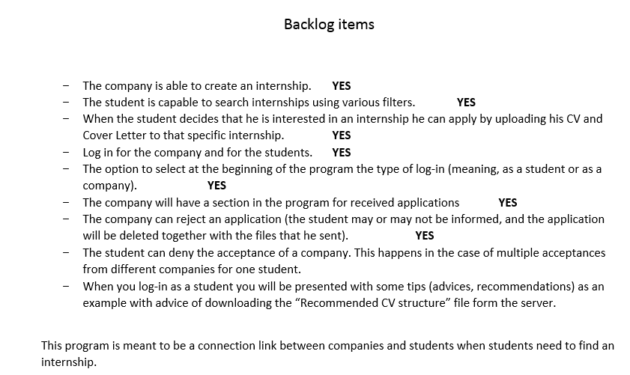**”**

In the inception phase we also did an E/R Model for the Database, which is a first thought upon what the Database should have, should be and should look like. You have it below just to have an idea.

